Question 11 pts

Which computation model is used to implement lexical analysis?

Group of answer choices

Tree automaton

Deterministic finite automaton

Pushdown automaton

Nondeterministic finite automaton

Question 21 pts

Consider the following grammar (the start symbol is S):

S → a A

A → a S | b S | ε

Which of the following strings is **not** in the language generated by the grammar?

Group of answer choices

aba

aaa

ab

a

Question 31 pts

Which of the following regular expressions can generate the string abab?

Group of answer choices

a*b*

a(ab)+b

a(ba)+b

a+b+

Question 41 pts

Which of the following is true about the automatons built from regular expressions?

Group of answer choices

The automaton contains as many states as many operators there are in the expression.

The automaton contains as many states as many symbols there are in the alphabet.

The automaton has as many accepting states as many strings the expression can generate.

The automaton contains a loop whenever the expression contains a * (or +) operator.

Which of the following compiler phases builds the structure tree of the input program?

Group of answer choices

Lexical analysis

Syntax analysis

Semantic analysis

Code generation

The primary role of programming language compilers is to …

Group of answer choices

Find logic errors and bugs in programs.

Analyze programs and translate them to other languages.

Specify/define programming languages.

Provide language servers for programming languages.

Which of the following statements is true?

Group of answer choices

Regular expressions are strictly more expressive than regular languages.

Any regular expression can be converted to an equivalent nondeterministic finite automaton.

Regular expressions have the same expressive power as context-free grammars.

Any context-free grammar can be converted to an equivalent deterministic finite automaton.

In the name SLR(1), the 1 means that the parser …

Group of answer choices

can only reduce handles of length 1.

uses 1 symbol lookahead to decide on the next action.

only supports grammars with at most 1 production rule for each nonterminal.

can predict the validity of the sentence based on its first symbol.

The syntax of programming languages can be defined with a …

Group of answer choices

Deterministic finite automaton

Regular grammar

Context-free grammar

Regular expression

What is the set of actions an LR parser can take?

Group of answer choices

derive, pop, accept, error

shift, reduce, accept, error

pop, push

accept, error

Predictive top-down parsing of a sentence yields the …

Group of answer choices

Leftmost derivation of the sentence.

The viable prefixes of the sentence.

Rightmost derivation of the sentence.

The handle of the sentence.

Consider the following regular expression:

ab*b+

Which of the following regular expressions generates the same language?

Group of answer choices

a(b*|b+)

ab+

ab*

a+b+

Consider the following grammar (the start symbol is S):

S → A a | b S a

A → S A S | b

What is the FOLLOW set of A?

Group of answer choices

{a, #}

{a}

{b, #}

{a, b}

Consider the following grammar (the start symbol is S):

S → x | A S

A → a S b

Which of the following is a maximal viable prefix?

Group of answer choices

xxx

aSbS

AAAAx

AAAaSbS

Consider the following grammar (the start symbol is S):

S → a B | a C

B → b | c

Which of the following statements is true?

Group of answer choices

The grammar is not regular.

The grammar is not LL(1).

The grammar’s language is infinite.

The grammar is not context-free.

Consider the following grammar (the start symbol is S):

S → A a | b S a

A → S A S | b

What is the FIRST set of A?

Group of answer choices

{b}

{a}

{a, b, ε}

{a, b}

Consider the following grammar (the start symbol is S):

S → a S | b A

A → c A | a b

What is the handle of the sentential form a a b c A?

Group of answer choices

a b

a A

c A

b A

Which of the following is a subset of the regular language defined by the regular expression a*b*c*|d?

Group of answer choices

{ad, bd, cd}

{a, b, c, d}

{abcd}

{ad, bd}

Consider the following grammar (the start symbol is S):

S → x | A S

A → a S b

Which of the following LR item sequences represents the viable prefix A A A x?

Group of answer choices

[S → A S .], [S → x .]

[S → A . S], [S → x .]

[S → x .]

[S → A . S], [S → A . S], [S → A . S], [S → x .]

Consider the following grammar (the start symbol is S):

S → x | A S

A → a S b

Suppose that the LR(0) parser is in configuration (#0, axbx#). What is the next step it takes?

Group of answer choices

accept

error

reduce

shift

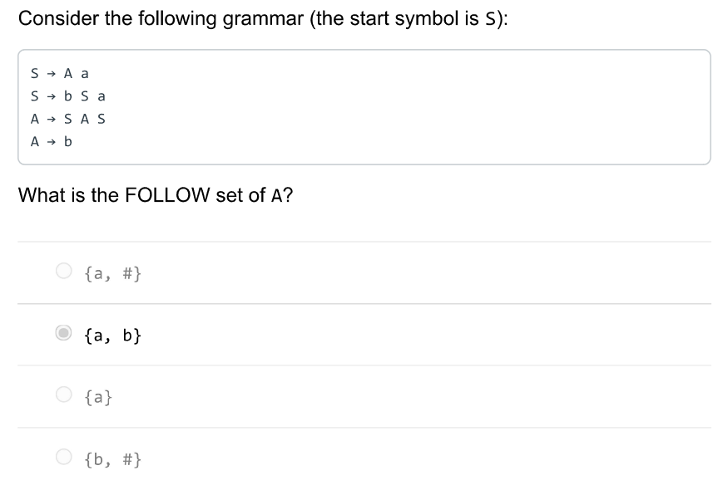

Consider the following grammar (the start symbol is S):

S-Aa

s->bsa

A->SAS

Ab

What is the FOLLOW set of A?

{a，#}

**{a, b)**

(a)

{b，#}

Consider the following regular expression:

(a)(a)(a)*

Which of the following regular expressions generates the same language?

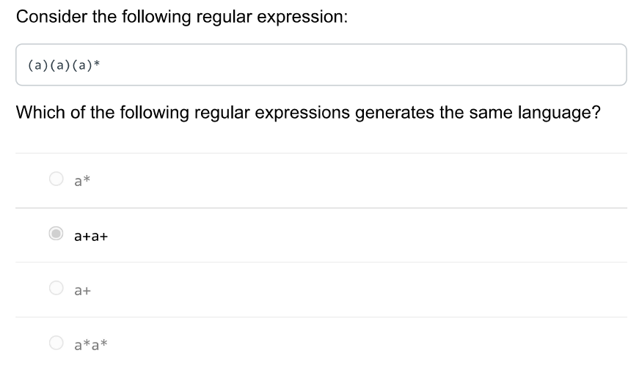

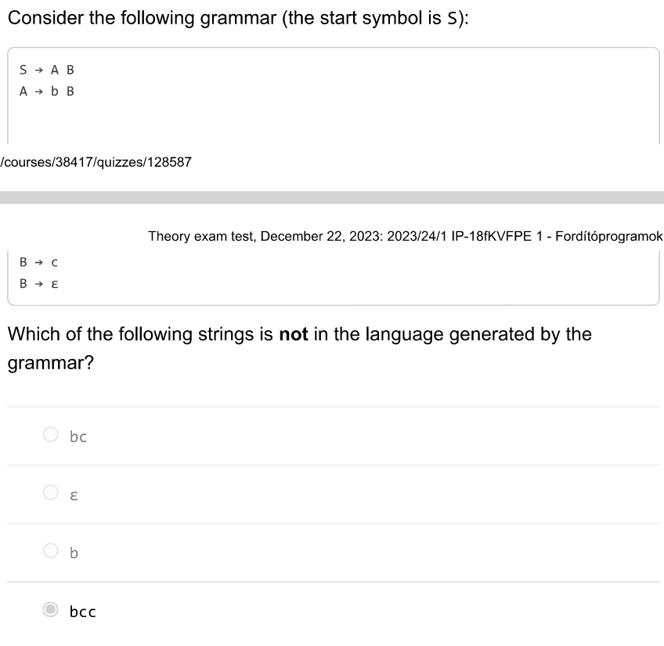

Which of the following strings is not in the language generated by the grammar?

bc

E

bcc

!empty!!!

云影:

Consider the following grammar (the start symbol is S):

5 → x

5 → A S

A → a 5 b

What's the relation between the sets FIRST(S) and FOLLOW(A)?

FIRST(S) = FOLLOW(A)

FIRST(S) = FOLLOW(A)

FIRST(S) < FOLLOW(A)

FIRST(S) ^ FOLLOW(A) = 0

云影:

Which of the following is true about epsilon-elimination in nondeterministic finite automatons?

It eliminates all states except those having epsilon-transitions.

It eliminates epsilon-transitions.C It eliminates states that have epsilon-transitions.

It makes the automaton deterministic.

云影:

Which of the following is a subset of the regular language defined by the regular expression ab*|a?

{a, ab}

云影:

Which of the following regular expressions can generate the string aaa?

(aa)*

ab*

aba*a*

ab*a*a

云影:

Predictive bottom-up parsing of a sentence yields the ...

rightmost derivation of the sentence.

云影:

Consider the following grammar (the start symbol is S):

S→ Ab

5 → Ac

A → a

Which of the following statements is true?

The grammar's language is infinite.

The grammar is not context-free.

The grammar is not LL(1).

云影:

The primary role of programming language compilers is to ...

analyze programs and translate them to other languages.

specify/define programming languages.

find logic errors and bugs in programs.

provide language servers for programming languages.

云影:

In the name SLR(1), the 1 means that the parser...

only supports grammars with at most 1 production rule for each nonterminal.

can predict the validity of the sentence based on its first symbol.

uses 1 symbol lookahead to decide on the next action.

can only reduce handles of length 1.

云影:

What do we use Thompson's construction for?

• Minimize a finite automaton into an equivalent finite automaton.

• Minimize a regular expression into an equivalent regular expression.

Transforming a regular expression into an equivalent nondeterministic finite automaton.

Transforming a nondeterministic finite automaton into an equivalent

云影:

Consider the following grammar (the start symbol is S):

S> ASIas

A →Ab|AC|d|E

What is the FIRST set of S?

｛a, b, C, d,E｝

O fa, b, c, dy

云影:

Which of the following regular expressions can generate the empty string?

a*b

at+

(ab)*

ab*

云影:

Consider the following grammar (the start symbol is S):

S → a A A → bA

A → cA

A → a b

What is the handle of the sentential form abcbA?

0 / 1 pts

ab

CA

bA